90

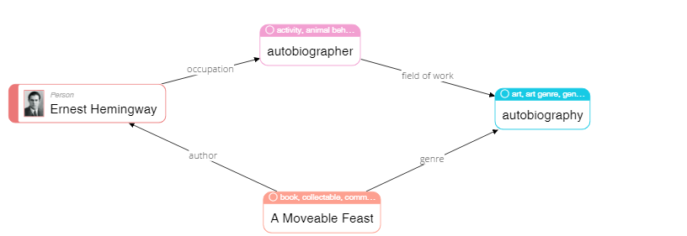

|  |
| --- |
| **Please describe shortly what you see on this diagram? Pay attention only to that information that is understandable or has sense for you.** |
| Ernest Hemingway is autobiographer and author of the “A Moveable Feast” book |

68

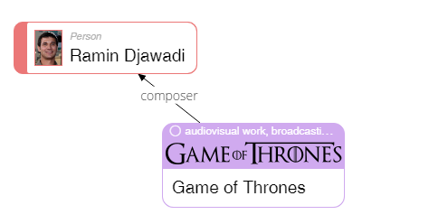

|  |
| --- |
| **Please describe shortly what you see on this diagram? Pay attention only to that information that is understandable or has sense for you.** |
| Ramin is a composer of Game Of Thrones serials, looks like he created soundtracks for this serials (audiovisual work?) |

23

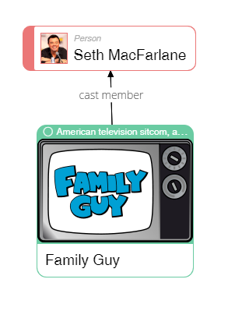

|  |
| --- |
| **Please describe shortly what you see on this diagram? Pay attention only to that information that is understandable or has sense for you.** |
| Seth was participating in some Family Guy episodes (or he is member of Family Guy audio-actors) |

50

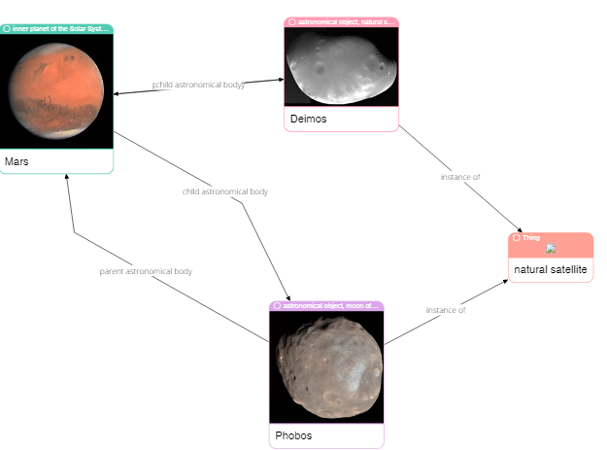

|  |
| --- |
| **Please describe shortly what you see on this diagram? Pay attention only to that information that is understandable or has sense for you.** |
| Mars is a planet with two neutral satellites – Phobos and Deimos |

62

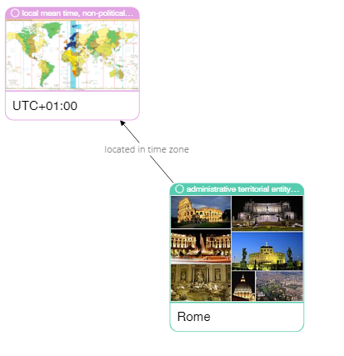

|  |
| --- |
| **Please describe shortly what you see on this diagram? Pay attention only to that information that is understandable or has sense for you.** |
| Rome has UTC +1 timezone |

75

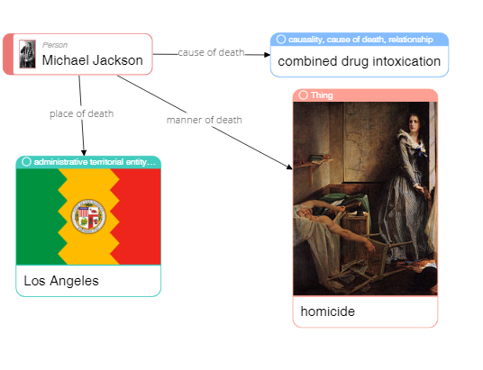

|  |
| --- |
| **Please describe shortly what you see on this diagram? Pay attention only to that information that is understandable or has sense for you.** |
| Michael Jackson died in LA because of drug intoxication (looks like he was murdered (homicide) by someone due overdose of few drugs (medicament or narcotic?)) |

79

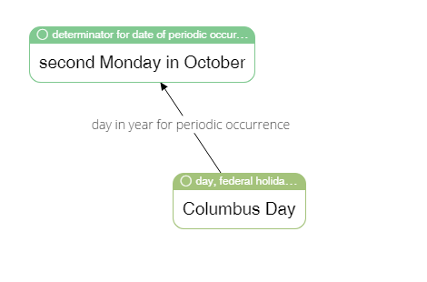

|  |
| --- |
| **Please describe shortly what you see on this diagram? Pay attention only to that information that is understandable or has sense for you.** |
| Second Monday in October is a Columbus Day and has periodic manner (yearly) |

65



|  |
| --- |
| **Please describe shortly what you see on this diagram? Pay attention only to that information that is understandable or has sense for you.** |
| Ole Kirk is joiner, carpenter and entrepreneur and he is creator of Lego constructor (not sure if he has patents or ownership of Lego corp. or logo) |

4

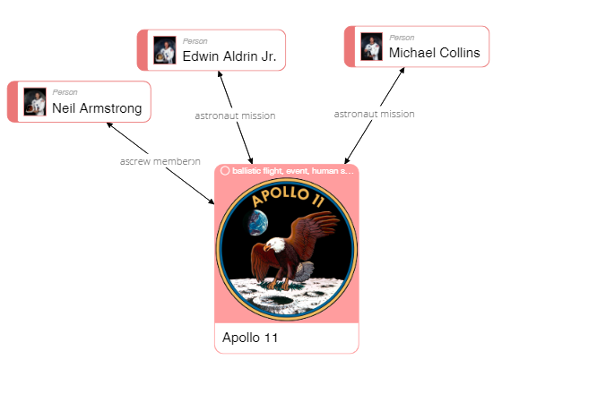

|  |
| --- |
| **Please describe shortly what you see on this diagram? Pay attention only to that information that is understandable or has sense for you.** |
| Neil, Edwin and Michael is astronauts and members of Apollo 11 mission. Not sure of reverse relatives, but the core idea is that. |

40

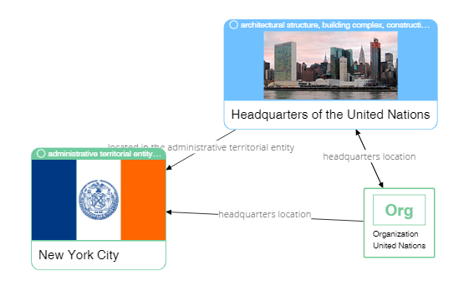

|  |
| --- |
| **Please describe shortly what you see on this diagram? Pay attention only to that information that is understandable or has sense for you.** |
| HQ of United Nations organization located in NYC |

37



|  |
| --- |
| **Please describe shortly what you see on this diagram? Pay attention only to that information that is understandable or has sense for you.** |
| “Estadio do Dragao” is a stadium which is located in Porto (city?) and also local football club HQ is in this city too |